DMC Mock State Target 1 & 2

- ________ Logan is constructing a scaled model of his town. The city's water tower is a cylinder with lateral surface area $1600$ square meters and holds $100,000$ liters of water. Logan's miniature water tower holds$0.1$ liters. What is the lateral surface area, in square meters, of his water tower?

- ________ Triangle $ABO$ has vertices $A(6, 12)$, $B(12, 9)$ and $O(1, 1)$. What is the area of triangle $ABO$?

DMC Mock State Target 3 & 4

- ________ The sum of a list of seven positive integers is $42$. The mean, median and mode are consecutive integers, in some order. What is the largest possible integer in the list?

- ________ Rays $AC$ and $AE$ intersect circle $O$ at $B$ and $D$, respectively. Segment $DE$ is a diameter of circle O and $AB=\frac{1}{2}DE$. If the measure of $BAD$ is 24 degrees, what is the degree measure of $COE$?
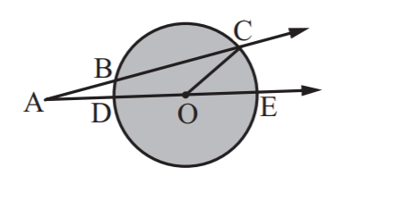

DMC Mock State Target 5 & 6

- ________ Let x, y and z be consecutive integers such that x < y < z. If (x + y)(x + z) = 9900, what is the value of x?

- ________ When Mandi shoots free throws, she consistently makes the shot with a probability of $p$, where $p<\frac{1}{2}$ . When she shoots six free throws, the probability that she makes exactly half of them is $\frac{4^{4}}{5^{5}}$. What is the value of $p$? Express your answer as a common fraction.

DMC Mock State Target 7 & 8

- ________ A circle passes through two diagonally opposite vertices of a 3-inch by 4-inch rectangle. What is the least possible distance between the center of the circle and a vertex of the rectangle? Express your answer as a common fraction.

- ________ A solid right, circular cone has a base radius of 5 meters and a slant height of 10 meters. A top cone will be removed so that the volume of the remaining frustum will be 1 3 that of the original cone. In square meters, what is the total surface area, including both bases, of the frustum? Express your answer to the nearest whole number.
