Denver Math Club – Geometry Handout – 8/30
- One angle of a triangle is equal to the sum of the other two; additionally, one of these angles is equal to 40$°$. What are the measures of the other two angles?

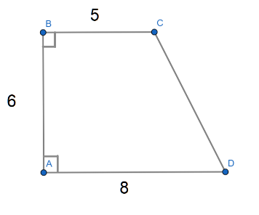
- The measures of two angles of an isosceles triangle are $3x+4°$ and $x+17°$. Find all possible values of $x$.

- Find the area of ABCD shown at right.
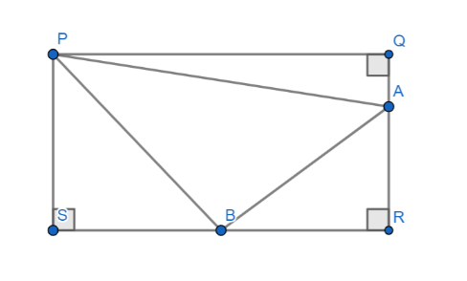

- In the diagram at left above, given [PQRS] = 5[PQA] and [PQRS] = 4[PBS], find [ABP]/[PQRS].

- The midpoints of the three sides of an equilateral triangle are connected to form a second triangle. A third triangle is formed by connecting the midpoints of the second triangle. This process is repeated until a tenth triangle is formed. What is the ratio of the perimeter of the tenth triangle to that perimeter of the third triangle?
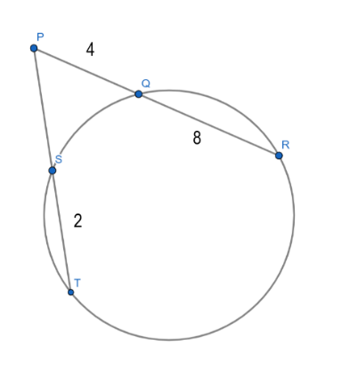
- A right triangle has area 210 and hypotenuse 29. Find the perimeter of the triangle.

- Find $PS$ in the diagram at right.

- A ladder is initially resting vertically against a wall that is perpendicular to the ground It begins to slip and fall to the ground, with the bottom of the ladder moving directly from the wall, and the top of the ladder always touching the wall. What path does the midpoint of the ladder trace? Why? Can you prove it?

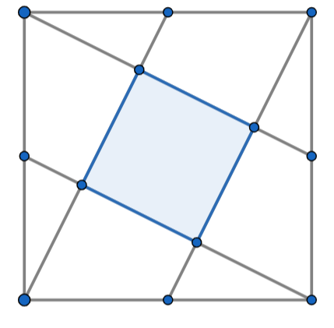
- Consider a square of side length 1, shown at right. We draw four lines that each connect a midpoint of a side with a corner not on that side, such that each midpoint and each corner is touched by only one of these lines as shown at left below. Find the area of the shaded region.

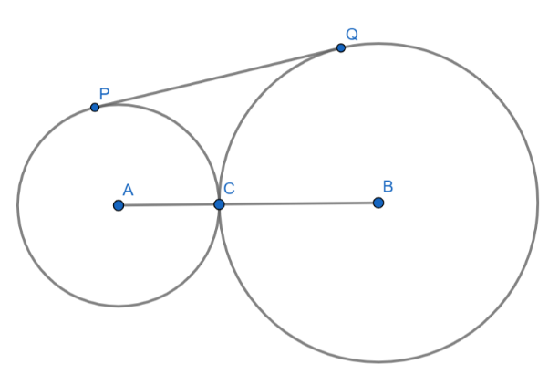
- Circles $ω_{1}$ and $ω_{2}$ with centers $A$ and $B$ are tangent at point $C$. $P$ is on $ω_{1}$ and $Q$ is on $ω_{2}$ such that $\overline{BQ}$ is tangent to both circles. Given $AC = 3$ and $BC = 8$, find $PQ$.

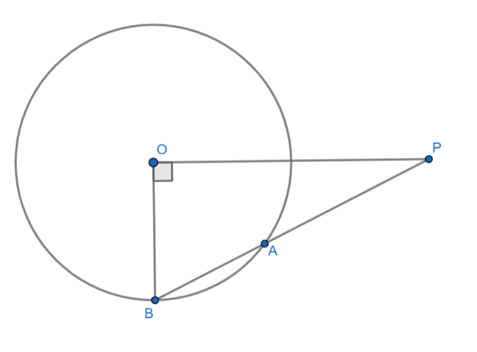

- In circle $O$ at right, $\overline{PO}⊥\overline{OB}$ and $PO$ equals the length of the diameter of $O$. Compute $PA/AB$.

- Find the largest value of $y/x$ for pairs of real numbers $\left(x,y\right)$ that satisfy ${\left(x-3\right)}^{2}+{\left(y-3\right)}^{2}=6$.

